Name: _____________________________________________________ Date: _________________ Period: _______
Lesson 1.2.6 Problems 1-114 to 1-118
1-114. For each part below, find a Giant One that will multiply the fraction on the left side of the equation to create the equivalent fraction on the right side of the equation. Then complete any other missing information.
a. 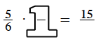 b. 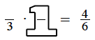

c. 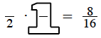 d. 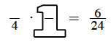

1-115. Fareed wants to add 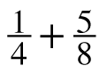.
a. Add the fractions by using a Giant One to create a common denominator.

b. How can factors help you find a common denominator?

1-116. Mario was visiting the carnival when he noticed a few number relationships. He made them into brainteasers for you.
a. If three tenths of the visitors were adults and there were 100 visitors, how many visitors were adults?

b. Five eighths of the prizes at the Giant Spin were dolls. If there were 64 prizes, how many prizes were not dolls?

1-117. Order these numbers from least to greatest:
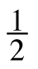
1.1 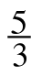 2 0 0.4 –2 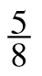

1st: ___________ 2nd: ___________ 3rd: ______________ 4th: ______________

5th: ___________ 6th: ___________ 7th: ______________ 8th: ______________

1-118. Find each sum.
a. $\frac{3}{5}+\frac{1}{3}$ b. $\frac{5}{7}+\frac{1}{2}$ c. $\frac{1}{6}+\frac{2}{8}$

